Study 1 — Can doxy-PEP for MSM bend the curve?
Methods: SHIELD is a compartment of syphilis epidemic in the US. The current model has been calibrated to available data from 1970 to 2021 in 10 high burden MSAs. We intentionally excluded all reported data from 2022 and 2023 when calibrating the baseline models to represent the doxycycline-free era.

Intervention: Beginning in 2023, Doxy-PEP is offered to sexually active MSM aged 15–65 years. Intervention coverage increases linearly from 2023 through 2030, reaching the target coverage level in 2030, after which coverage is maintained over time. Doxy-PEP effectiveness is estimated from clinical trials and represented as a combined measure of adherence and biological effectiveness in reducing the risk of transmission following sexual contact. We evaluate a range of intervention scenarios with target coverage levels from 10% to 50% of eligible MSM by 2030.

Research questions:
- Policy target:
What level of Doxy-PEP coverage among MSM is needed to achieve a 50% reduction in syphilis incidence by 2030 compared with the 2022 baseline?
- Added value/impact:
Compared with a no-intervention scenario, how does Doxy-PEP coverage affect syphilis incidence and the number of cases averted among MSM by 2030?
- Broader population impact:
What are the indirect effects of Doxy-PEP use among MSM on syphilis incidence among women and heterosexual men by 2030?

Why do we need both 1 and 2? Because incidence rose steeply in the absence of intervention, a given level of Doxy-PEP can prevent a large fraction of projected infections while still leaving incidence at or above its 2022 level. The two framings answer different questions, and the gap between them widens with the growth rate of the underlying epidemic
Primary outcomes:
- Syphilis incidence: The number of new syphilis infections occurring in a given population during a specified period.
- Total syphilis diagnoses: The total number of syphilis diagnoses recorded in a given year.
- Proportion of incident syphilis among MSM: The proportion of incident syphilis infections occurring among MSM.
Secondary outcome
- P&S syphilis diagnoses: The number of primary and secondary (P&S) syphilis diagnoses, representing stages most proximate to recent infection.
- Detection rate: The ratio of P&S syphilis diagnoses to incident syphilis infections in the same year.

Correlates of Variation in Doxy-PEP Spillover
The projected Doxy-PEP impact at the total-population level in SHIELD reflects reductions in incidence among MSM, females, and heterosexual males. Whereas the impact among MSM represents the direct effect of Doxy-PEP through reduced susceptibility among users and subsequent reductions in transmission, the impact among females and heterosexual males is primarily a population-level spillover effect arising from reduced transmission from MSM to their sexual partners. To characterize the extent to which reductions among females tracked those observed among MSM, we defined a spillover coefficient as the ratio of the projected reduction in incident infections among females to the corresponding projected reduction among MSM by 2030, comparing scenarios with and without Doxy-PEP. A spillover value of 0 indicates no reduction among females, value of 1 indicates reductions of similar magnitude among females and MSM, and a value >1 indicates greater reductions among females than among MSM.
We then explored associations between the spillover coefficient and baseline MSA-level characteristics that could plausibly be related to the magnitude of spillover, including the proportion of incident infections occurring among MSM, MSM incidence rate, female incidence rate, the MSM-to-female incidence rate ratio, the proportion of the male population identifying as MSM, and the rate of syphilis detection (diagnoses per incident infection), all measured in 2022.
Changes in the underlying epidemic trajectory in the absence of intervention could also be associated with the projected magnitude of spillover. To capture differences in epidemic trajectories across MSAs, we defined a divergence factor as the natural logarithm of the ratio of heterosexual to MSM incidence growth between 2022 and 2030. Incidence growth was measured as the fold change in incidence between 2022 and 2030 for each population. A divergence factor of zero indicates proportional changes in incidence of the same magnitude in the two populations; positive values indicate relatively greater growth or smaller declines in heterosexual incidence than in MSM incidence, whereas negative values indicate the opposite pattern.

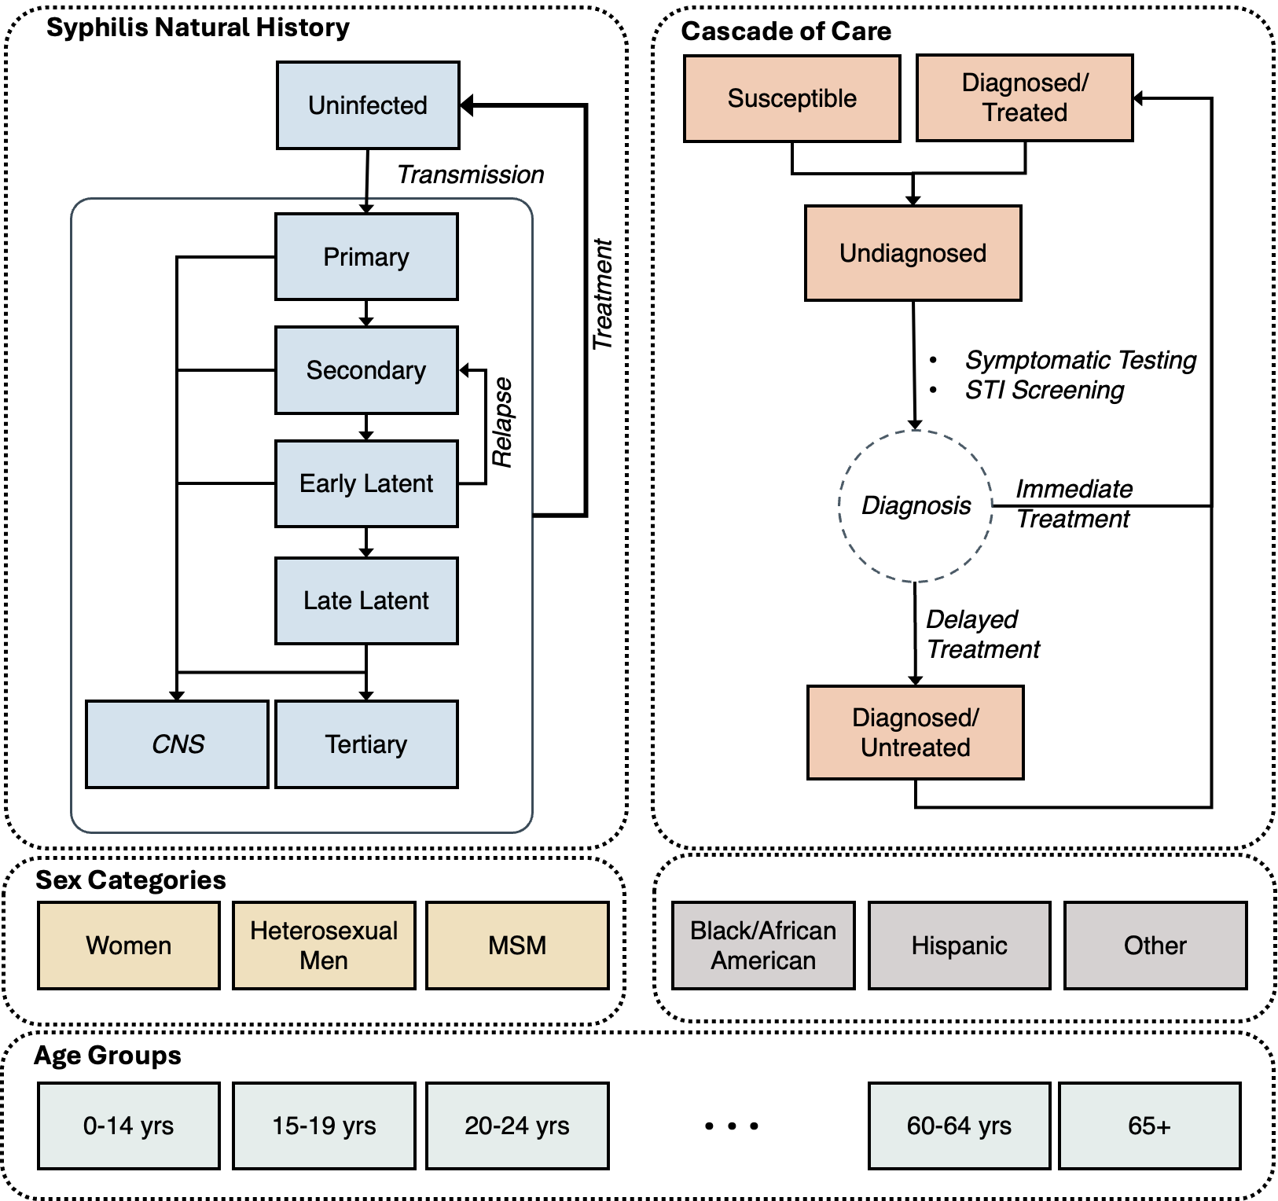

Results

Baseline projections without Doxy-PEP, 2022-2030
In the absence of DoxyPEP, the syphilis epidemic was projected to continue growing over the next decade in nine of the ten modeled MSAs: Between 2022 and 2030, the population incidence rate was projected to rise by a median of 3.4-fold, ranging from 1.4-fold in Atlanta (95% CrI 1.13–1.75) to 5.3-fold in Houston (4.17–6.77) – Table1. By 2030, the greatest burden was projected in Houston (960 per 100,000 person-years; 718–1,356), followed by Phoenix (844; 558–1,085) and Miami (792; 471–1,045) – Figure1. Baltimore was the exception, with a projected fold-change of 0.72 (0.53–1.24) in incidence rate between 2022 and 2030. Rates of primary and secondary (P&S) diagnosis were projected to rise in parallel across the nine growing MSAs, from 15–38 to 28–142 per 100,000 person-years. The detection ratio (P&S diagnoses per incident infection) had a median of 0.20 across the ten modeled MSAs in 2022 (range 0.12–0.27) and declined modestly to 0.17 by 2030 (range 0.10–0.28), indicating that most incident infections were not detected during the primary or secondary stage, when infectiousness is greatest.
Subgroup projections showed a consistent shift in the composition of the epidemic. Across all modeled MSAs except Atlanta and Baltimore, the MSM share of incident infections was projected to decline, from a 2022 range of 28–59% to a 2030 range of 6–37%, such that women and heterosexual men together were projected to account for the majority of new infections (63–94%) by 2030. The relative decline was largest in Chicago (31% to 6%), Phoenix (28% to 11%), and LA (29% to 12%). Atlanta and Baltimore were the exceptions, with MSM remaining the predominant risk group through 2030, accounting for 70% (51–75) and 60% (37–77) of incident infections, respectively – Figure 1D.

Table 1: Projected trend in syphilis epidemiology in absence of Doxy-PEP, 2022-2030
MSA | Incidence rate (per 100,000 persons), 2022 | Incidence rate (per 100,000 persons), 2030 | Fold-change in incidence rate, 2030 vs 2022 | Total diagnosis rate (per 100,000 persons), 2022 | Total diagnosis rate (per 100,000 persons), 2030 | P&S diagnoses per incident infection, 2022 | P&S diagnoses per incident infection, 2030 | MSM share of incidence (%), 2022 | MSM share of incidence (%), 2030
Atlanta | 101 | 138 | 1.37 | 86 | 121 | 0.21 | 0.2 | 67 | 70
 | [88-119] | [107-190] | [1.13-1.75] | [79-95] | [98-155] | [0.19-0.22] | [0.19-0.21] | [60-70] | [51-75]
Baltimore | 67 | 50 | 0.72 | 63 | 52 | 0.27 | 0.28 | 53 | 60
 | [60-84] | [32-106] | [0.53-1.24] | [59-72] | [39-94] | [0.27-0.28] | [0.27-0.28] | [43-63] | [37-77]
Chicago | 77 | 217 | 2.77 | 55 | 107 | 0.2 | 0.17 | 31 | 6
 | [67-93] | [102-439] | [1.45-5.29] | [51-59] | [66-187] | [0.17-0.21] | [0.13-0.18] | [27-36] | [3-10]
Houston | 182 | 960 | 5.3 | 103 | 551 | 0.12 | 0.1 | 38 | 19
 | [165-211] | [718-1356] | [4.17-6.77] | [97-109] | [441-725] | [0.11-0.13] | [0.08-0.1] | [32-42] | [14-24]
LA | 182 | 406 | 2.2 | 109 | 225 | 0.15 | 0.12 | 29 | 12
 | [156-203] | [178-968] | [1.13-4.8] | [102-114] | [138-407] | [0.14-0.17] | [0.11-0.16] | [25-37] | [6-33]
Miami | 230 | 792 | 3.41 | 148 | 467 | 0.13 | 0.11 | 53 | 34
 | [208-256] | [471-1045] | [2.13-4.5] | [139-157] | [321-562] | [0.12-0.14] | [0.1-0.13] | [48-60] | [27-54]
NYC | 103 | 340 | 3.32 | 77 | 216 | 0.19 | 0.17 | 59 | 37
 | [95-115] | [248-525] | [2.41-5.08] | [73-85] | [176-296] | [0.18-0.2] | [0.16-0.18] | [57-63] | [31-50]
Philadelphia | 87 | 291 | 3.38 | 59 | 176 | 0.23 | 0.22 | 47 | 24
 | [75-99] | [152-438] | [1.96-4.83] | [54-64] | [108-235] | [0.21-0.25] | [0.18-0.24] | [42-53] | [14-40]
Phoenix | 209 | 844 | 3.99 | 111 | 449 | 0.18 | 0.17 | 28 | 11
 | [187-238] | [558-1085] | [2.84-4.99] | [104-119] | [327-532] | [0.16-0.2] | [0.15-0.2] | [24-32] | [8-15]
Seattle | 99 | 388 | 3.89 | 61 | 215 | 0.24 | 0.23 | 38 | 18
 | [78-116] | [204-516] | [2.15-5.11] | [50-68] | [124-275] | [0.22-0.25] | [0.21-0.25] | [31-44] | [11-27]

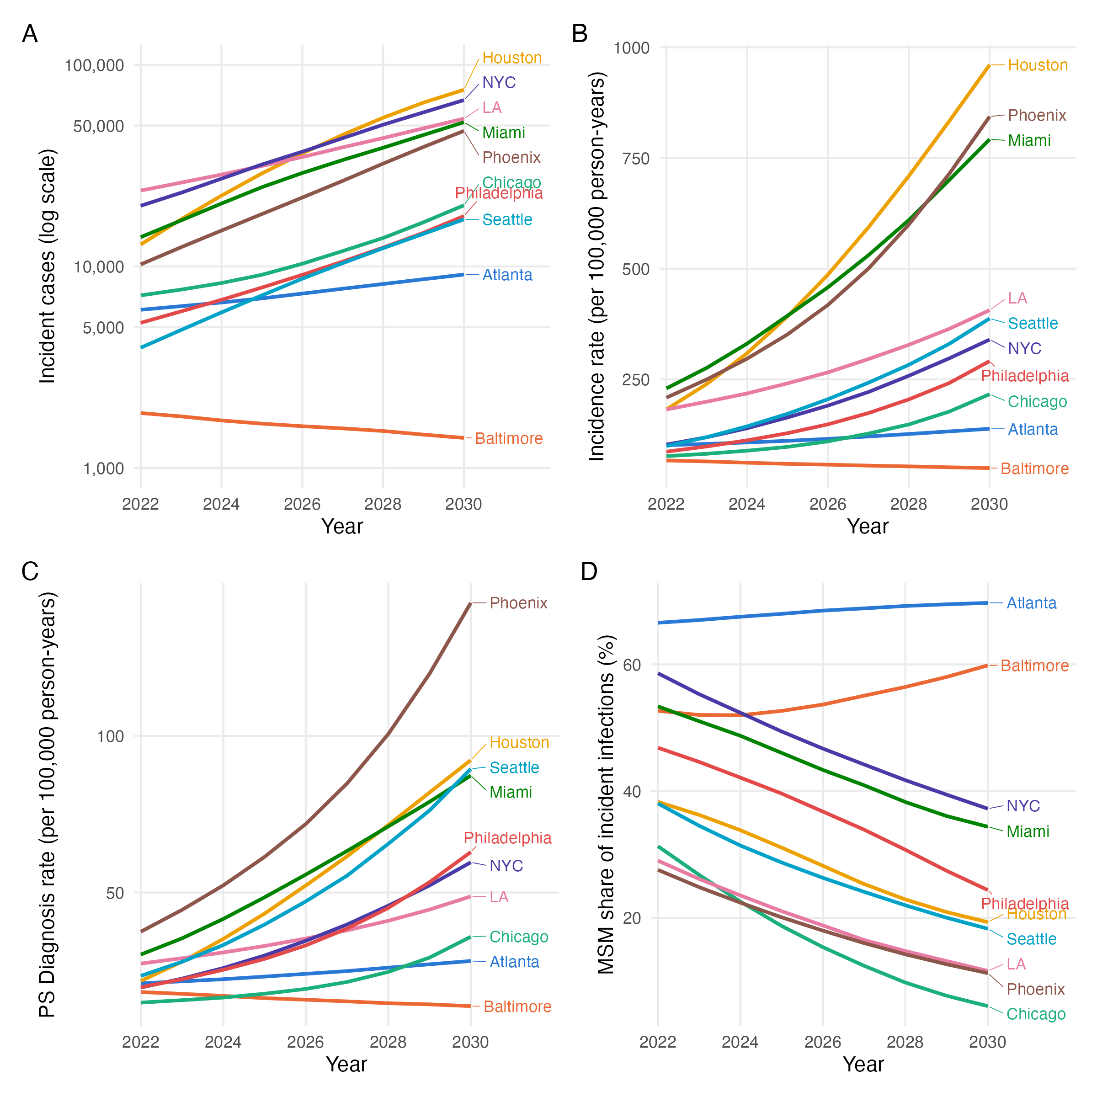
Figure 1. Projected syphilis incidence at baseline in the absence of Doxy-PEP.
Figures show projected number of incident syphilis cases on a log scale (Panel A), incidence rates per 100,000 person-years (Panel B), PS Diagnosis rates per 100,000 person-years (Panel C) and the percentage of MSM of incident syphilis infections (Panel D) across 10 modeled MSAs from 2022 to 2030. Lines represent the projected median across 400 posterior simulations for each MSA.

Critical Doxy-PEP coverage needed to reach 50% recutions
Among MSM, the DoxyPEP coverage required to halve incidence relative to its 2022 level varied roughly four-fold across MSAs (Figure 2A). Baltimore and Chicago had already exceeded a 50% reduction at the lowest modeled coverage of 10% (54% and 64%, respectively); LA reached the target at 20%; Atlanta, NYC, Philadelphia, Phoenix and Seattle at 30%; and Houston and Miami at 40%. By 2030, all ten MSAs achieved at least a 50% reduction in MSM incidence relative to 2022, with a median critical coverage of 30%.
Measured against the no-intervention counterfactual in the same year rather than against 2022, the same coverage levels averted considerably more infections (Figure 2C). At 20% coverage every MSA averted at least half of MSM incidence (range 51–69%), and at 50% coverage, 88–95% of infections were averted. The divergence between the two measures was widest where the underlying epidemic grew fastest: in Houston, 30% coverage left MSM incidence only 17% below its 2022 level yet averted 72% of the infections projected to occur without DoxyPEP.
Impact on the total population was consistently smaller and far more heterogenous: Compared with 2022 levels, most MSAs did not achieve meaningful reductions in total-population incidence under the modeled scenarios (Figure 2C). The main exceptions were Atlanta and Baltimore, where Doxy-PEP rollout was projected to reduce total-population incidence by more than 50% at 30% and 10% coverage, respectively. Relative to the no-intervention projection for 2030, the median proportion of total-population incidence averted was 21% at 10% coverage and increased to 62% at 50% coverage (Figure 2D). The critical coverage required to achieve a 50% reduction in total-population incidence varied substantially across MSAs, ranging from 20% in Atlanta to 50% in Houston; Chicago and LA did not reach this target at any modeled coverage level.
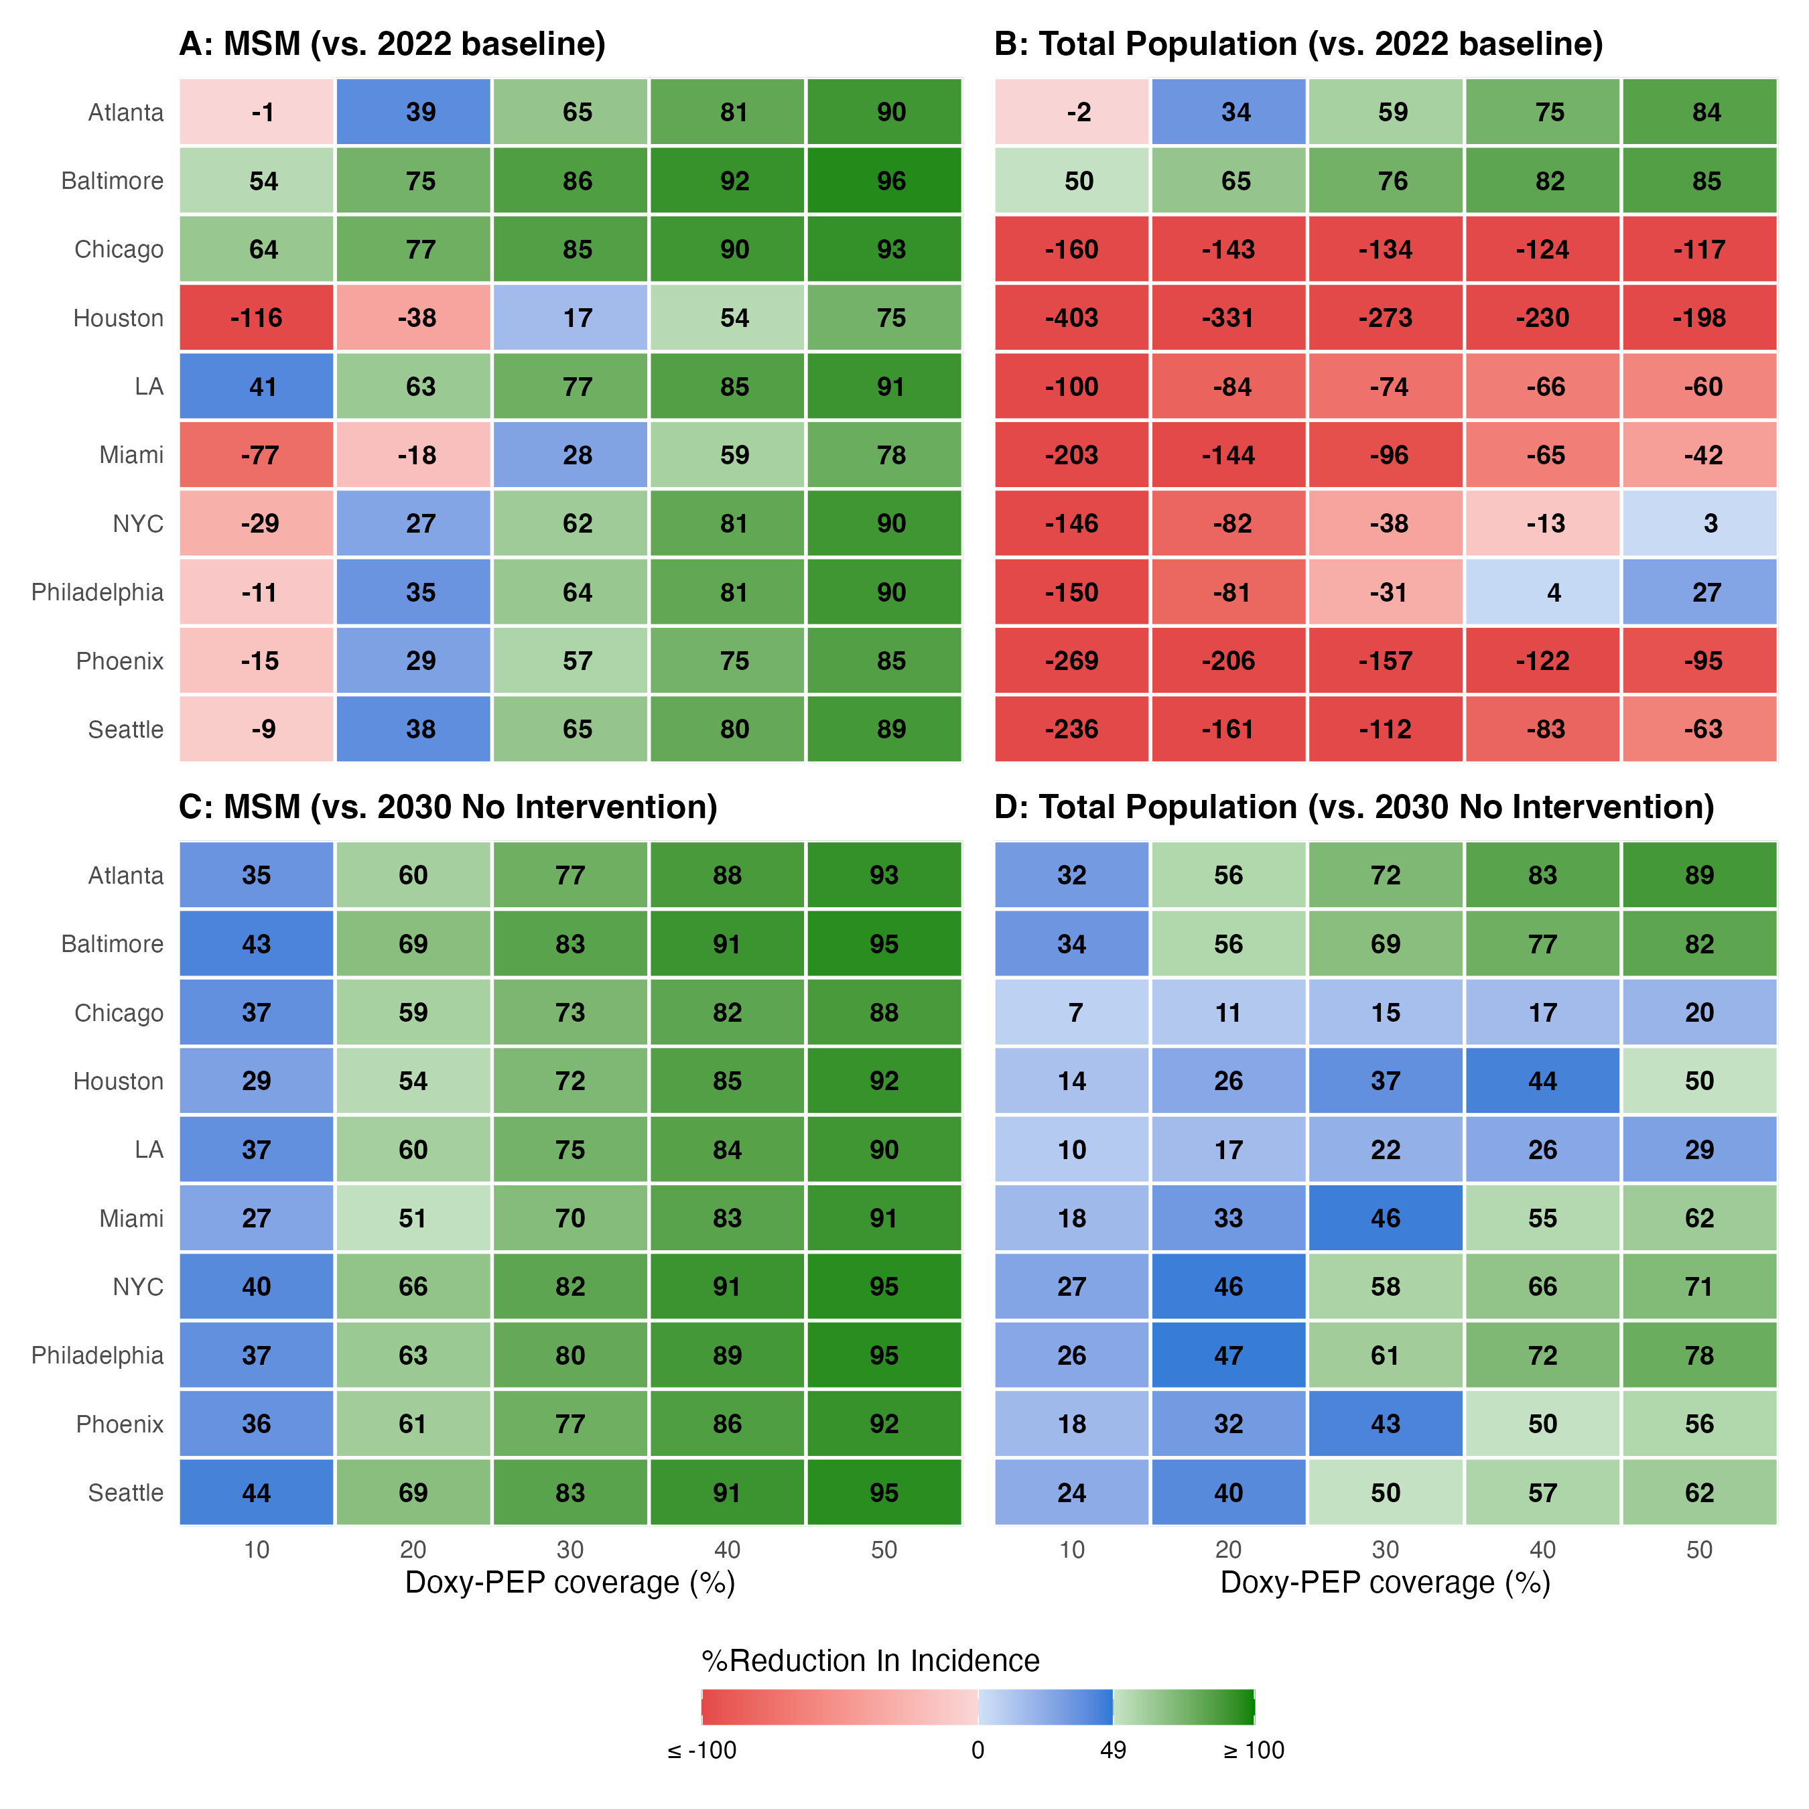Figure 2. Projected effect of DoxyPEP on syphilis incidence in 2030 across ten US MSAs, by coverage level. Each cell shows the median projected percentage change in syphilis incidence in 2030 under DoxyPEP coverage of 10% to 50% (x-axis). The two row-pairs use different comparators. Panels A and B represent incidence reduction relative to the 2022 baseline: positive values indicate incidence has fallen below its 2022 level, negative values indicate it remains above it despite DoxyPEP. Panels C and D represent incidence reduction relative to the no-intervention counterfactual in the same year: positive values are infections averted by DoxyPEP. Panels A and C are restricted to MSM; panels B and D show the total population. Cells are colored across span three categories: red below 0, blue from 0 to 49%, green at or above 50%. Cell values are medians across 400 posterior simulations. MSAs are ordered based on Panel A.

Doxy-PEP Impact
Under the modeled scenarios with 30% Doxy-PEP coverage, Doxy-PEP was projected to avert a median of XX% of incident syphilis infections across the 10 MSAs by 2030, ranging from 15% in Chicago to 72% in Atlanta (Table2). These reductions corresponded to more than 493,000 infections averted by 2030. Reductions were greatest among MSM, ranging from 70% in Miami to 83% in Seattle. Projected reductions among females and heterosexual males were lower but broadly similar across MSAs. Among females, 30% Doxy-PEP coverage was projected to result in a median XX% reduction in incidence, ranging from 11% in Chicago to 62% in Atlanta; corresponding reductions among heterosexual males were 10.7% in Chicago and 64% in Atlanta, respectively.

Correlates of Doxy-PEP Impact
Projected spillover varied substantially across MSAs (Figure 2). The spillover coefficient, representing the projected reduction in female incidence relative to the reduction among MSM, ranged from 0.15 in Chicago to 0.80 in Atlanta. Among the factors examined, the strongest association was observed with baseline female incidence in 2022 (Spearman’s $ρ=-0.59$, Figure 2A), with MSAs having lower female incidence generally experiencing greater projected spillover from Doxy-PEP. The proportion of incident infections occurring among MSM was positively associated with the spillover coefficient, as was the MSM-to-female incidence rate ratio in 2022 (Figure 2B-C). Together, these associations suggest that spillover was greater in MSAs where the underlying syphilis burden was more concentrated among MSM relative to females.
For example, Atlanta and Chicago illustrated opposite ends of this spectrum. Atlanta had the lowest baseline female incidence (29 per 10,000 persons), with 69% of incident infections occurring among MSM and an MSM-to-female incidence rate ratio of 0.84, and was among the MSAs projected to experience the greatest spillover impact (0.80). In contrast, Chicago had a lower proportion of incident infections occurring among MSM (31%) and a substantially lower MSM-to-female incidence rate ratio (0.25), and experienced the smallest spillover coefficient (0.15). Together, these patterns suggest that greater concentration of the syphilis burden among MSM relative to females was associated with greater projected spillover to females.
Furthermore, the epidemic divergence factor, which captured the relative trajectory of heterosexual versus MSM incidence in the absence of intervention, was negatively associated with the spillover coefficient (Spearman’s $ρ=-0.54$, Figure 2D). MSAs in which heterosexual incidence was projected to grow faster relative to MSM incidence tended to experience smaller reductions in female incidence attributable to Doxy-PEP. Conversely, greater alignment between the heterosexual and MSM epidemic trajectories was associated with greater projected spillover among females.
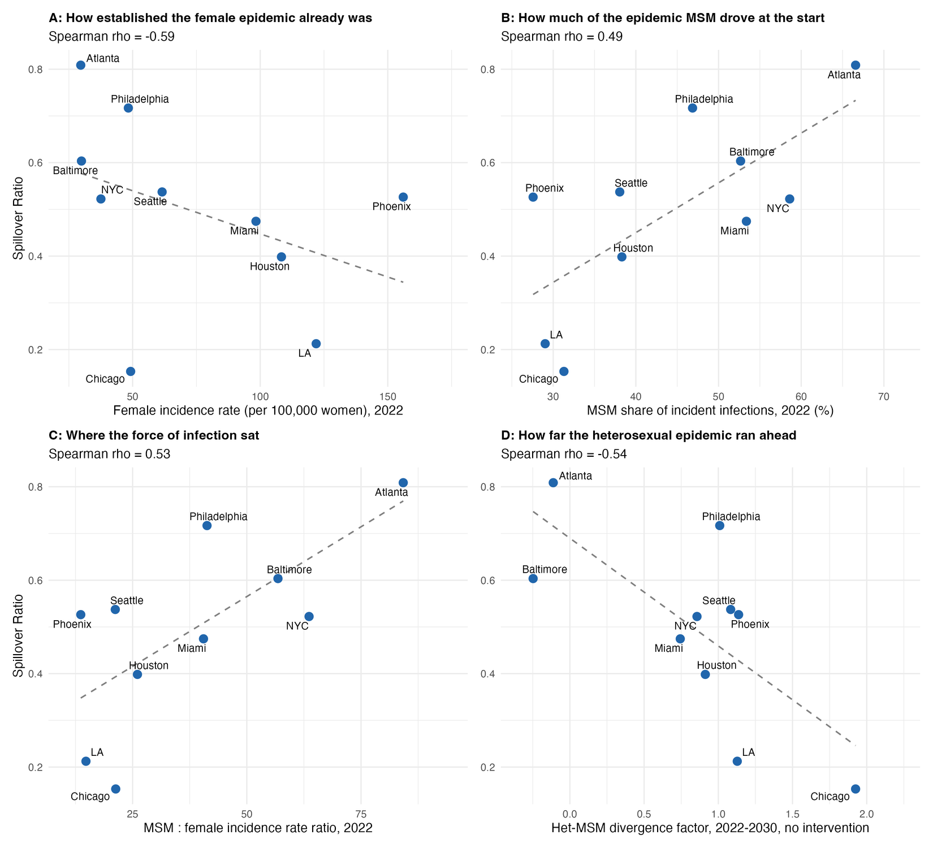
Figure 2. Variation in projected Doxy-PEP spillover across modeled MSAs. The spillover coefficient, shown on the y-axis, was calculated as the proportional reduction in female syphilis incidence relative to the proportional reduction in MSM incidence by 2030 under 30% Doxy-PEP coverage. Greater values indicate a greater proportional reduction among females. Each panel shows the association between the spillover coefficient and a different MSA-level factor shown on the x-axis, including female syphilis incidence rate in 2022 (per 100,000 persons) in Panel A; proportion of incident syphilis infections occurring among MSM in 2022 in Panel B; MSM-to-female syphilis incidence rate ratio in 2022 in Panel C; and the Het-MSM divergence factor, calculated as the natural logarithm of the ratio of heterosexual to MSM incidence fold-change between 2022 and 2030 in Panel D. Spearman rank correlation coefficients ($ρ$) are shown at the top of each panel. Dashed line represents the fitted linear regression for each factor.

Table 2: Projected Impact of Doxy-PEP reaching 30% coverage by 2030.
MSA | Population | Incidence 2022, No Intervention | Incidence 2030, No Intervention | Incidence 2022, Doxy Coverage 30% | Incidence 2030, Doxy Coverage 30% | Incidence Rate (per 100,0000 population) 2022, No Intervention | Incidence Rate (per 100,0000 population) 2030, No Intervention | Incidence Rate (per 100,0000 population) 2022, Doxy Coverage 30% | Incidence Rate (per 100,0000 population) 2030, Doxy Coverage 30% | Incidence averted (%), 2030 | Incidence averted per 100,000 population, 2030 | Cumulative infections averted, 2022-2030
Atlanta | Total | 6098 | 9117 | 6098 | 2470 | 101 | 138 | 101 | 38 | 72.4 | 99 | 24492
 |  | [5388-7250] | [7241-12238] | [5388-7250] | [1610-4180] | [88-119] | [107-190] | [88-119] | [23-64] | [64.2-78.8] | [80.2-129.8] | [20209-31284]
Baltimore | Total | 1875 | 1412 | 1875 | 449 | 67 | 50 | 67 | 16 | 69.3 | 33.9 | 3988
 |  | [1664-2349] | [920-3068] | [1664-2349] | [245-1287] | [60-84] | [32-106] | [60-84] | [9-45] | [50.1-79.5] | [20.2-62.4] | [2649-6726]
Chicago | Total | 7187 | 20100 | 7187 | 17101 | 77 | 217 | 77 | 182 | 14.7 | 34.8 | 11218
 |  | [6291-8708] | [9374-40913] | [6291-8708] | [7455-36748] | [67-93] | [102-439] | [67-93] | [79-397] | [8.1-22.8] | [16.1-52] | [5855-16642]
Houston | Total | 12846 | 75203 | 12846 | 48031 | 182 | 960 | 182 | 609 | 36.7 | 346.7 | 89991
 |  | [11791-14825] | [57067-106465] | [11791-14825] | [31901-76361] | [165-211] | [718-1356] | [165-211] | [408-973] | [27.7-44.8] | [279.7-410.9] | [73077-106652]
LA | Total | 23782 | 54087 | 23782 | 42452 | 182 | 406 | 182 | 319 | 22 | 94.8 | 43006
 |  | [20407-26602] | [22679-123353] | [20407-26602] | [12308-107976] | [156-203] | [178-968] | [156-203] | [95-837] | [12-50.6] | [68.8-128.1] | [34780-56220]
Miami | Total | 13973 | 51891 | 13973 | 27851 | 230 | 792 | 230 | 426 | 46.2 | 356.8 | 79003
 |  | [12588-15878] | [29225-69033] | [12588-15878] | [11651-44155] | [208-256] | [471-1045] | [208-256] | [189-670] | [35-60.1] | [271.9-424.6] | [60744-92325]
NYC | Total | 19993 | 66834 | 19993 | 27600 | 103 | 340 | 103 | 141 | 58.2 | 196.5 | 127224
 |  | [18503-22337] | [46951-104566] | [18503-22337] | [16949-50508] | [95-115] | [248-525] | [95-115] | [89-253] | [48.9-67.2] | [146.3-290.9] | [98266-180436]
Philadelphia | Total | 5253 | 17779 | 5253 | 6734 | 87 | 291 | 87 | 110 | 61.5 | 180.2 | 33331
 |  | [4558-5927] | [9633-26881] | [4558-5927] | [2602-13618] | [75-99] | [152-438] | [75-99] | [41-222] | [46.4-73.8] | [107.8-241.3] | [23362-43272]
Phoenix | Total | 10234 | 47014 | 10234 | 26616 | 209 | 844 | 209 | 482 | 42.7 | 349.1 | 56900
 |  | [9185-11598] | [31174-59866] | [9185-11598] | [14493-41032] | [187-238] | [558-1085] | [187-238] | [260-737] | [30.7-54.6] | [246.9-443.4] | [41548-73341]
Seattle | Total | 3953 | 17125 | 3953 | 8362 | 99 | 388 | 99 | 188 | 50.3 | 181 | 24328
 |  | [3111-4593] | [8888-23488] | [3111-4593] | [3955-14457] | [78-116] | [204-516] | [78-116] | [88-322] | [36.2-61.5] | [106.6-283.4] | [15820-36518]
Atlanta | msm | 4008 | 6097 | 4008 | 1407 | 2499 | 3428 | 2499 | 792 | 77.2 | 2650.3 | 18248
 |  | [3664-4836] | [5194-8187] | [3664-4836] | [966-2431] | [2254-3095] | [2879-4681] | [2254-3095] | [517-1413] | [68-82.6] | [2226.3-3397.3] | [15391-23255]
Baltimore | msm | 985 | 816 | 985 | 134 | 1701 | 1358 | 1701 | 221 | 82.8 | 1133.6 | 2973
 |  | [806-1233] | [439-1599] | [806-1233] | [67-337] | [1335-2105] | [691-2529] | [1335-2105] | [106-549] | [75.1-86.4] | [568.8-2054.6] | [1806-4866]
Chicago | msm | 2309 | 1323 | 2309 | 351 | 1049 | 601 | 1049 | 158 | 73.3 | 427.6 | 4733
 |  | [1895-2712] | [539-2194] | [1895-2712] | [158-550] | [885-1210] | [244-969] | [885-1210] | [72-247] | [63.2-79.2] | [161.1-745] | [2361-7618]
Houston | msm | 4854 | 14784 | 4854 | 4028 | 2823 | 7732 | 2823 | 2107 | 72.4 | 5555 | 40346
 |  | [4355-5357] | [11762-17043] | [4355-5357] | [2765-5835] | [2539-3179] | [6453-8844] | [2539-3179] | [1498-3021] | [63.2-78.7] | [4535-6419.4] | [32791-46776]
LA | msm | 6839 | 6258 | 6839 | 1581 | 1803 | 1681 | 1803 | 422 | 74.9 | 1240.2 | 20696
 |  | [6221-7917] | [4690-8463] | [6221-7916] | [938-2634] | [1602-2044] | [1246-2290] | [1602-2044] | [253-718] | [65.4-81.3] | [985.8-1674.9] | [17485-29198]
Miami | msm | 7430 | 17961 | 7430 | 5326 | 3984 | 8909 | 3984 | 2645 | 70.3 | 6205.1 | 48312
 |  | [6611-8671] | [12491-24353] | [6611-8671] | [2192-9268] | [3505-4338] | [6229-11076] | [3505-4338] | [1128-4315] | [58.5-82.8] | [5017.7-7187.1] | [38287-57819]
NYC | msm | 11763 | 25257 | 11763 | 4482 | 2390 | 5024 | 2390 | 896 | 82.4 | 4119.2 | 76989
 |  | [10746-13492] | [18804-37598] | [10746-13491] | [2626-9315] | [2143-2784] | [3737-7534] | [2143-2784] | [534-1762] | [73.8-86.6] | [3189-5895] | [60054-107899]
Philadelphia | msm | 2476 | 4380 | 2476 | 895 | 1995 | 3396 | 1995 | 699 | 79.5 | 2688.4 | 13300
 |  | [2220-2773] | [3483-5738] | [2220-2773] | [605-1411] | [1714-2311] | [2662-4547] | [1714-2311] | [471-1117] | [71.2-84.3] | [2111.6-3559.7] | [10722-16545]
Phoenix | msm | 2846 | 5114 | 2846 | 1213 | 2131 | 3412 | 2131 | 804 | 76.5 | 2590.9 | 14879
 |  | [2462-3239] | [4121-5903] | [2462-3239] | [873-1659] | [1830-2464] | [2756-3977] | [1830-2464] | [579-1109] | [69.5-80.7] | [2099.6-2980] | [11894-17042]
Seattle | msm | 1439 | 2763 | 1439 | 494 | 1305 | 2161 | 1305 | 397 | 83.1 | 1781.5 | 8602
 |  | [1191-1805] | [1741-5047] | [1191-1805] | [264-871] | [1052-1638] | [1408-4118] | [1052-1638] | [213-708] | [76.9-86.6] | [1186.8-3462.7] | [5974-15037]
Atlanta | female | 921 | 1231 | 921 | 451 | 30 | 37 | 30 | 13 | 62.4 | 23.3 | 2639
 |  | [763-1184] | [815-2697] | [763-1184] | [247-1238] | [25-38] | [24-82] | [25-38] | [7-37] | [53.1-69.7] | [15.7-44.8] | [1863-4499]
Baltimore | female | 432 | 276 | 432 | 152 | 30 | 19 | 30 | 10 | 50 | 9.1 | 491
 |  | [295-567] | [143-770] | [295-567] | [51-480] | [21-39] | [10-52] | [21-39] | [3-32] | [32.9-66] | [5.5-19.1] | [314-860]
Chicago | female | 2354 | 8973 | 2354 | 7835 | 49 | 186 | 49 | 162 | 11.2 | 22.9 | 3107
 |  | [2069-3040] | [4117-18583] | [2069-3040] | [3439-17176] | [43-64] | [85-389] | [43-64] | [72-355] | [6.6-17.4] | [10.6-34.6] | [1595-4547]
Houston | female | 3857 | 28450 | 3857 | 20259 | 108 | 720 | 108 | 509 | 28.8 | 206.5 | 24493
 |  | [3361-4924] | [20063-42764] | [3361-4924] | [13249-32956] | [94-138] | [504-1066] | [94-138] | [337-826] | [20.8-37] | [151.6-251.5] | [18236-31262]
LA | female | 8096 | 22245 | 8096 | 18881 | 122 | 331 | 122 | 280 | 15.9 | 55.2 | 10794
 |  | [6267-9462] | [7810-53966] | [6267-9462] | [4939-49321] | [94-142] | [117-827] | [94-142] | [75-746] | [8.6-37.1] | [37.2-78.5] | [8099-14662]
Miami | female | 3083 | 15570 | 3083 | 10452 | 98 | 457 | 98 | 310 | 33.4 | 148.9 | 14228
 |  | [2577-3577] | [7460-23045] | [2577-3577] | [4206-17228] | [82-113] | [231-682] | [82-113] | [127-513] | [24.1-45.9] | [100-190.4] | [9955-17978]
NYC | female | 3759 | 18893 | 3759 | 10600 | 38 | 187 | 38 | 106 | 43 | 80.6 | 22580
 |  | [3334-4193] | [11838-31527] | [3334-4193] | [5830-19350] | [33-42] | [120-308] | [33-42] | [59-189] | [35.8-52.6] | [54.4-124.1] | [15882-33037]
Philadelphia | female | 1518 | 6775 | 1518 | 2833 | 48 | 216 | 48 | 91 | 57 | 122.2 | 10578
 |  | [1178-1743] | [2976-10962] | [1178-1743] | [979-6005] | [38-56] | [93-343] | [38-56] | [30-189] | [41.9-69.8] | [61.7-167.3] | [6311-14043]
Phoenix | female | 3861 | 20033 | 3861 | 11880 | 156 | 717 | 156 | 426 | 40.3 | 276.7 | 21760
 |  | [3391-4563] | [13087-26318] | [3391-4563] | [6408-18727] | [137-184] | [468-939] | [137-184] | [225-661] | [27.8-52.5] | [189.1-372.7] | [15362-30183]
Seattle | female | 1235 | 6647 | 1235 | 3618 | 62 | 297 | 62 | 163 | 44.6 | 126 | 7760
 |  | [963-1468] | [3358-9467] | [963-1468] | [1697-6467] | [48-73] | [153-417] | [48-73] | [76-286] | [31.3-55.2] | [71-184.5] | [4827-10975]
Atlanta | heterosexual_male | 1120 | 1545 | 1120 | 551 | 40 | 49 | 40 | 18 | 64 | 32.7 | 3403
 |  | [929-1386] | [1022-3074] | [929-1386] | [303-1392] | [33-50] | [33-103] | [33-50] | [10-46] | [53.8-71.4] | [22.8-57.4] | [2470-5277]
Baltimore | heterosexual_male | 471 | 308 | 471 | 166 | 36 | 23 | 36 | 12 | 52.3 | 12.2 | 582
 |  | [342-607] | [170-836] | [342-607] | [63-523] | [27-47] | [13-63] | [27-47] | [5-39] | [32.6-69.9] | [7.6-24.9] | [390-1006]
Chicago | heterosexual_male | 2474 | 9988 | 2474 | 8955 | 57 | 234 | 57 | 203 | 10.7 | 26.7 | 3193
 |  | [2172-3180] | [4501-20819] | [2172-3180] | [3784-19284] | [49-73] | [106-486] | [49-73] | [88-452] | [6.4-16.4] | [12.6-40.1] | [1676-4671]
Houston | heterosexual_male | 4143 | 32230 | 4143 | 23407 | 124 | 876 | 124 | 632 | 27.2 | 234.1 | 25553
 |  | [3625-5184] | [22960-49633] | [3625-5184] | [15353-39363] | [108-155] | [617-1333] | [108-155] | [421-1049] | [19.7-34.8] | [176.3-286.8] | [19643-32113]
LA | heterosexual_male | 8840 | 25622 | 8840 | 21990 | 146 | 415 | 146 | 359 | 15.1 | 66 | 11442
 |  | [6816-10444] | [8732-61223] | [6816-10444] | [5690-56137] | [111-171] | [142-1045] | [111-171] | [94-948] | [8.2-34.9] | [43.5-95.4] | [8301-15809]
Miami | heterosexual_male | 3427 | 17536 | 3427 | 11964 | 124 | 594 | 124 | 408 | 32.9 | 190.6 | 15800
 |  | [2883-3974] | [8420-26248] | [2883-3974] | [4737-19727] | [105-144] | [300-879] | [105-144] | [166-670] | [23.6-45.4] | [127.9-241.7] | [11019-19930]
NYC | heterosexual_male | 4436 | 22540 | 4436 | 12551 | 50 | 248 | 50 | 140 | 43.7 | 109.5 | 27294
 |  | [3921-4974] | [14592-37795] | [3921-4974] | [6986-23245] | [44-56] | [165-413] | [44-56] | [79-254] | [35.7-53.1] | [77.3-165.7] | [20328-39064]
Philadelphia | heterosexual_male | 1260 | 6713 | 1260 | 3038 | 45 | 238 | 45 | 106 | 54.2 | 129.5 | 9634
 |  | [943-1617] | [2587-11755] | [943-1617] | [909-6695] | [33-58] | [91-413] | [33-58] | [31-237] | [39.9-66.9] | [59.2-185.7] | [5111-13129]
Phoenix | heterosexual_male | 3575 | 21613 | 3575 | 13478 | 155 | 827 | 155 | 519 | 37 | 295.9 | 20185
 |  | [2885-4054] | [13507-28524] | [2885-4054] | [7146-20911] | [125-177] | [521-1100] | [125-177] | [274-807] | [25.5-48.3] | [199.3-383.6] | [14195-26774]
Seattle | heterosexual_male | 1228 | 7324 | 1228 | 4180 | 65 | 351 | 65 | 201 | 42.1 | 141.2 | 7796
 |  | [946-1507] | [3611-10733] | [946-1507] | [1918-7524] | [50-80] | [176-504] | [50-80] | [90-354] | [29.7-52.3] | [78-199.8] | [4678-10855]

Extensions?
The baseline projects MSM share falling to 6% in Chicago and 11–12% in Phoenix and LA. That drives your central negative finding (limited total-population impact), and it will be the first thing a reviewer attacks, because it runs against what most US P&S surveillance currently shows. The model is calibrated only through 2021 with 2022–23 held out, so the heterosexual expansion is extrapolated ~9 years beyond data. I'd add a sensitivity analysis or at minimum an explicit paragraph defending it — arguably co-equal in priority with writing §3.
-issue: rate_incidence_averted_per_msm is total incidence/msmpopulation….it should be incidentMSM/msm.pop correct? we need subgroup rates
Lower baseline female incidence was associated with greater projected spillover. This pattern may reflect differences in the relative concentration of transmission within MSM sexual networks and the resulting potential for downstream reductions among female partners, although the association may also partly reflect the proportional construction of the spillover coefficient

Key calibration figures
All models are calibrated to data available to the end of 2021. The intentionally excluded data from 2022 and 2023 to make sure that the baseline projections represent a Doxy free era.

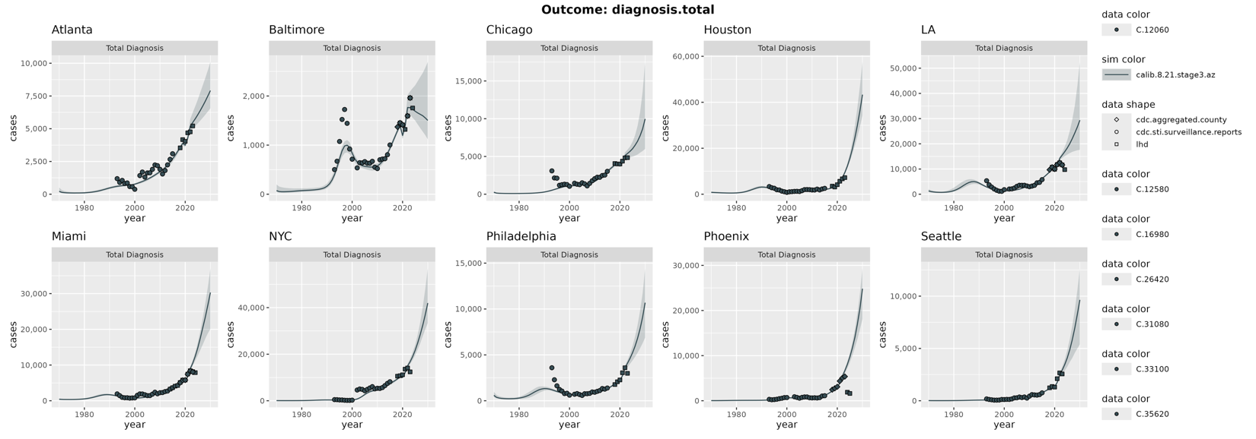
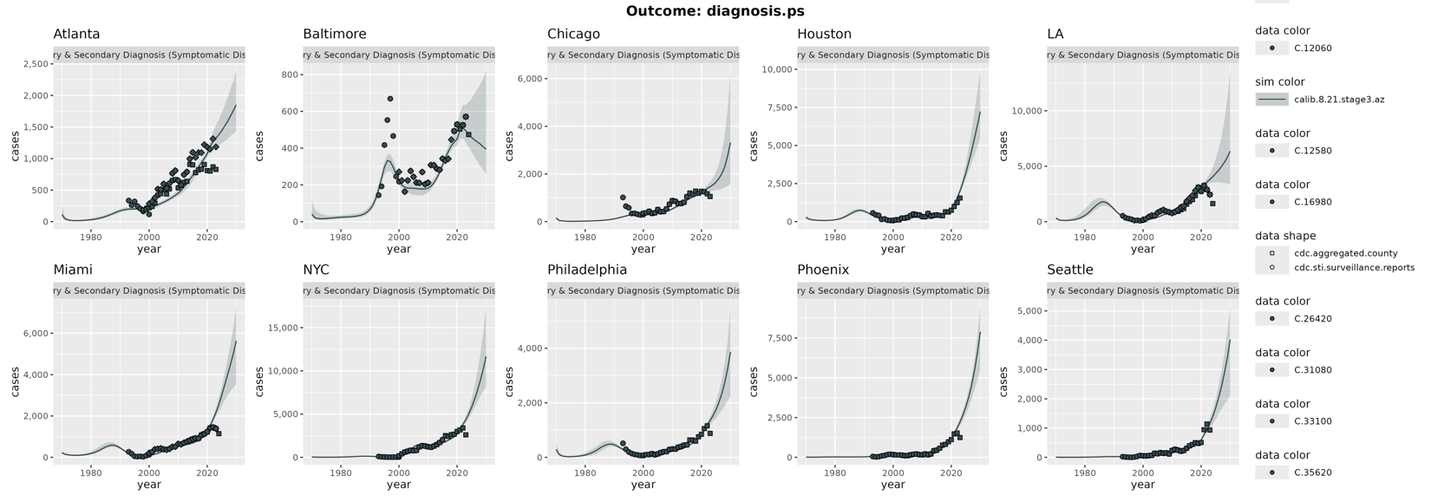
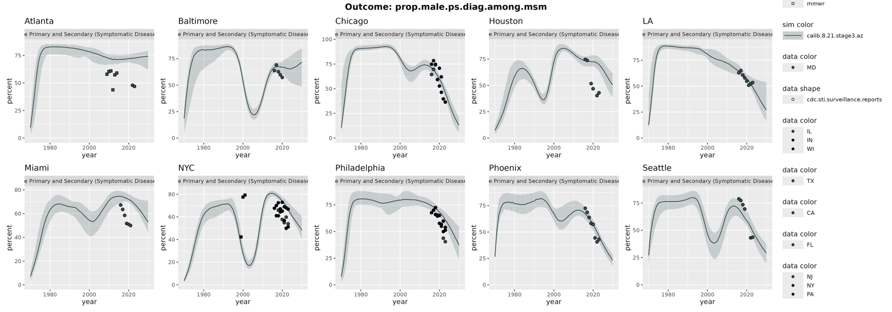

Key questions: what proportion of eligible MSM receive Doxy each year and are protected against transmission?

# | Question | Output | How we measure it in the model
Q1 | Can Doxy-PEP alone bend the curve at all? | Critical coverage per MSA; controllable / not | Impose coverage directly at fixed C; sweep C from 0 to 1 in 0.05 steps, run to 2040.  Ccrit is the lowest C at which incidence is declining  1-among MSM; 2-at the population level.  (e.g. Ccrit_MSM maybe 40% and Ccrit_all maybe Null, meaning no amount of doxy scale up among MSM can bend the curve for other groups)  An MSA is classified not controllable if no C ≤ 1 satisfies this.
Q2 | What coverage gets 90% reduction in MSM incidence by 2030 relative to baseline (2026)? | Minimum C by effectiveness level | Same imposed-C sweep, evaluated at 2030 rather than at equilibrium.  For each e, find the smallest C at which MSM incidence in 2030 is ≤10% of the 2026 counterfactual.
Q3 | What's the indirect impact on heterosexual men and women? | % reduction in non-MSM diagnoses | Same runs as Q1/Q2, no additional simulation. Stratify incidence and diagnosis outputs by MSM / heterosexual male / female and compare to the no-doxy counterfactual.  Effects propagate only through the bridging terms in the mixing matrix.  Also report averted infections decomposed into direct (among covered individuals) vs. indirect (among the uncovered, including all non-MSM).  To extend to congenital syphilis (while we don’t model it directly), report reductions in female (ages 15-45) incidence → childbearing ages.
Q4  Not for now | Is elimination achievable at best case? | Time to threshold, or not reached | Optimistic corner only (~3 runs per MSA): C = 1.0, e at the upper efficacy bound, imposed instantaneously in 2022. Extend the horizon well past 2050 and record the first year MSM incidence falls below the elimination threshold and stays there. Report separately for MSM and non-MSM. Where the threshold is never crossed, report the asymptotic incidence floor instead — that floor identifies what sustains transmission (importation, bridging, or latent-stage duration).

